**Project Design Phase-II**

**Data Flow Diagram & User Stories**

|  |  |
| --- | --- |
| Date | 31 January 2025 |
| Team ID |  |
| Project Name |  |
| Maximum Marks | 4 Marks |

**Data Flow Diagrams:**

A Data Flow Diagram (DFD) is a traditional visual representation of the information flows within a system. A neat and clear DFD can depict the right amount of the system requirement graphically. It shows how data enters and leaves the system, what changes the information, and where data is stored.

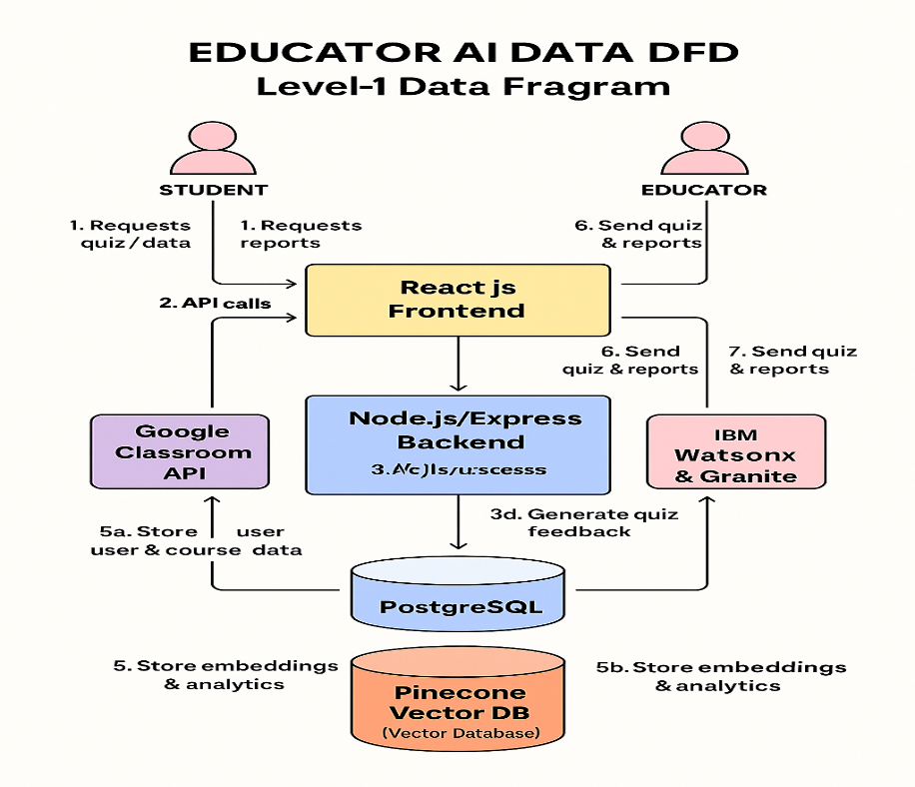

Example: DFD Level 0 (Industry Standard)

* Students/Educators send requests via the React.js frontend.
* Frontend routes requests to the Node.js/Express backend.
* Backend synchronizes rosters with Google Classroom and submits quiz-generation requests to AI services.
* AI services return dynamically generated questions and feedback.
* Backend persists profiles in PostgreSQL and analytical vectors in Pinecone.
* Backend returns quizzes, scores, and performance heatmaps to the frontend.
* Frontend renders results for students and educators.

**User Stories**

Use the below template to list all the user stories for the product.

| **User Type** | **Functional Requirement (Epic)** | **Story #** | **User Story / Task** | **Acceptance Criteria** | **Priority** | **Release** |
| --- | --- | --- | --- | --- | --- | --- |
| Student (Web) | User Registration | USN-1 | As a student, I can register with email and password so that I can create my Edu Tutor AI account. | • I complete registration form • I receive a “Welcome” email • I land on my student dashboard | High | Sprint-1 |
| Student (Web) | User Registration | USN-2 | As a student, I can register via Google Classroom SSO so that I sync my courses automatically. | • I authenticate with Google • My courses list appears in the dashboard | Medium | Sprint-1 |
| Student (Web) | User Confirmation | USN-3 | As a student, I receive a confirmation email after registration so that my account is verified. | • I get an email with a confirmation link • Clicking the link marks my account as “Verified” on UI | High | Sprint-1 |
| Student (Web) | Quiz & Assessment Management | USN-4 | As a student, I can take a diagnostic test so that the system measures my proficiency level. | • I complete at least 10 questions • I see a summary report with strengths/weaknesses | High | Sprint-2 |
| Student (Web) | Quiz & Assessment Management | USN-5 | As a student, I can take an adaptive quiz so that questions adjust to my performance in real time. | • Each question adapts based on my previous answers • I receive instant feedback after each question | High | Sprint-2 |
| Educator (Web) | LMS Integration & Analytics Reporting | USN-6 | As an educator, I can sync my class roster from Google Classroom so that Edu Tutor AI mirrors my current student list. | • I initiate sync • Student names/IDs import successfully • I see the updated roster in “My Classes” | High | Sprint-2 |
| Educator (Web) | LMS Integration & Analytics Reporting | USN-7 | As an educator, I can view a class performance heatmap so that I identify topic-level strengths and gaps. | • Dashboard heatmap loads within 2 s • Weakest three topics are highlighted per student | Medium | Sprint-3 |
| Educator (Web) | Quiz & Assessment Management | USN-8 | As an educator, I can generate a custom quiz on selected topics so that I target areas needing reinforcement. | • I select topics and question count • A quiz preview appears • I can export the quiz or launch it directly for my class | Medium | Sprint-3 |
| Admin (Web) | User Confirmation / Security Monitoring | USN-9 | As an admin, I can view unverified accounts so that I can resend confirmation emails or deactivate stale registrations. | • I see a list of unverified users older than 24 h • I can select users and resend confirmation in bulk | Low | Sprint-4 |
| Admin (Web) | Analytics Reporting & Performance Monitoring | USN-10 | As an admin, I can monitor system health metrics (API latency, error rate) so that I ensure platform reliability. | • A dashboard shows real-time latency and error rate • Alerts trigger if latency > 2 s or error rate > 5 % | Medium | Sprint-4 |